Moholy-Nagy, László (1895–1946)

Born in Bácsborsód, Hungary, László Moholy-Nagy was one of the most influential teachers, designers, and theoreticians of 20th century Modernism. As a professor at the Bauhaus (1923-28) and a central figure of International Constructivism, he pioneered modern interdisciplinary art and design practice and opposed traditional media hierarchies, thereby heralding the post-war media art revolution. In 1922, with Alfréd Kemény he authored ‘Dynamic-Constructive Energy System,’ a manifesto of kinetic, participatory art applied in his proposal for an immersive *Kinetic-Constructive System* (1928). In 1922-23 he prefigured conceptual art in the *Emaille* series, ordered from an enamel sign-maker using graph-paper sketches and standardised colours. In *Malerei, Photographie, Film* (1927), a key manifesto of 20th-century media art, he regarded technology as an extension of our sensorium, influencing media theorists Walter Benjamin, Sigfried Giedion, and Marshall McLuhan. Regarding light as “raw material,” Moholy-Nagy saw painting as just one possible form of “light art.” He conceptualized expanded cinema and coined the term “New Vision” to refer to his call for sensory training and his reform of photography based on the camera’s technical capabilities. His mechanized *Light Prop for an Electric Stage* (1930) projected kinetic coloured light patterns, establishing kinetic light art. With Walter Gropius he edited *bauhaus* (1926-28) and the *bauhausbücher* series (1925-29).

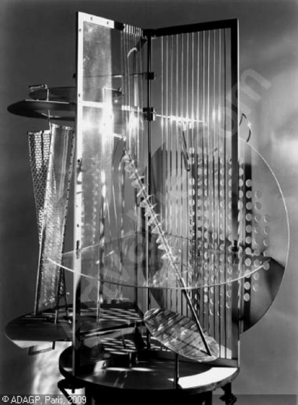

Moholy-Nagy began legal studies in 1913 and joined Lajos Kassák’s Budapest “Activist” group in 1918. Kassak’s Socialism and the 1919 Hungarian Soviet Republic instilled in him a lifelong universalist utopianism. In 1920 he settled in Berlin, where Raoul Hausmann’s and Kurt Schwitters’ inter-medial Dada art broadened his notion of art. He learned of Biocentrism and Reform Pedagogy through his first wife Lucia Moholy. Encountering Russian Constructivism in 1921, he began making material constructions and abstract paintings influenced by Kasimir Malevich and El Lissitzky. With Kassák he edited *Book of New Artists* (1921-22), an influential compendium of art, music, technical, and architectural photographs. During the 1920s Moholy-Nagy made photograms, photographs, and photomontages that influenced contemporary practice. After the Bauhaus, he pursued a successful design practice in Berlin (1928-34). Partly with the assistance of his second wife Sibyl, he made a series of documentary films about urban life (1929-33). The deteriorating situation in Germany induced him to move to Amsterdam and then London (1934-35). In 1937 he became Director of the “New Bauhaus” in Chicago. He opened the School of Design in 1939 (“Institute of Design” after 1943) and remained president until his death. *Vision in Motion* and *The New Vision* are among the most influential post-war art and design treatises. The Budapest University of Art and Design was re-named in his honour in 2006.

**References and further reading:**

- Botar, Oliver, *Technical Detours: The Early Moholy-Nagy Reconsidered*, 2006.

- David, Catherine, ed., *László Moholy-Nagy*, 1991.

- Engelbrecht, Lloyd, *Moholy-Nagy: Mentor to Modernism*, 2009.

- Haus, Andreas, *Moholy-Nagy: Fotos und Fotogramme*, 1978.

- Heyne, Renate, Floris M. Neusüss, Hattula Moholy-Nagy, eds., *Moholy-Nagy. The Photograms. Catalogue Raisonné*, 2009.

- Hight, Eleanor. *Picturing Modernism: Moholy-Nagy and Photography in Weimar Germany*, 1995.

- Hug, Andreas and Hattula Moholy-Nagy eds., moholy-nagy.org

- Lusk, Irene-Charlotte. *Montagen ins Blaue*, 1980.

- Moholy-Nagy, László, *Malerei, Photographie, Film*, 1925 (1927)

-----, *Von Material zu Architektur*, 1929

-----, *The New Vision*, 1932

-----, *Vision in Motion*, 1947.

- Passuth, Krisztina. *Moholy-Nagy*, 1982.